In-Class Assignment -1

Kartik Velede

8672807

Branding - Style Guides – INFO8920

Joseph Olubobokun

August – 13 – 2020

August – 13 – 2020

1) Creating the spcolor file using the SharePoint Color Palette Tool and customized the look of five UI Groups:

* + Suite Bar
  + Navigation
  + Header
  + Lines
  + Emphasis

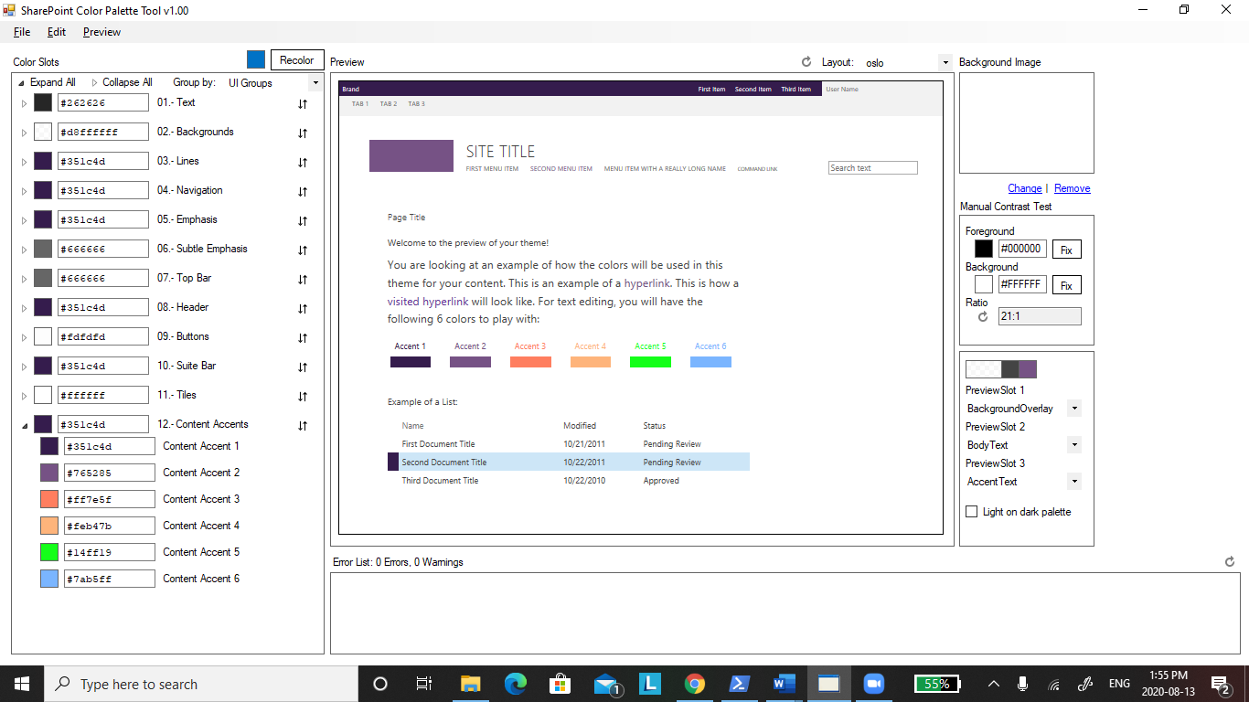

2) Now uploading the saved spcolor to the theme

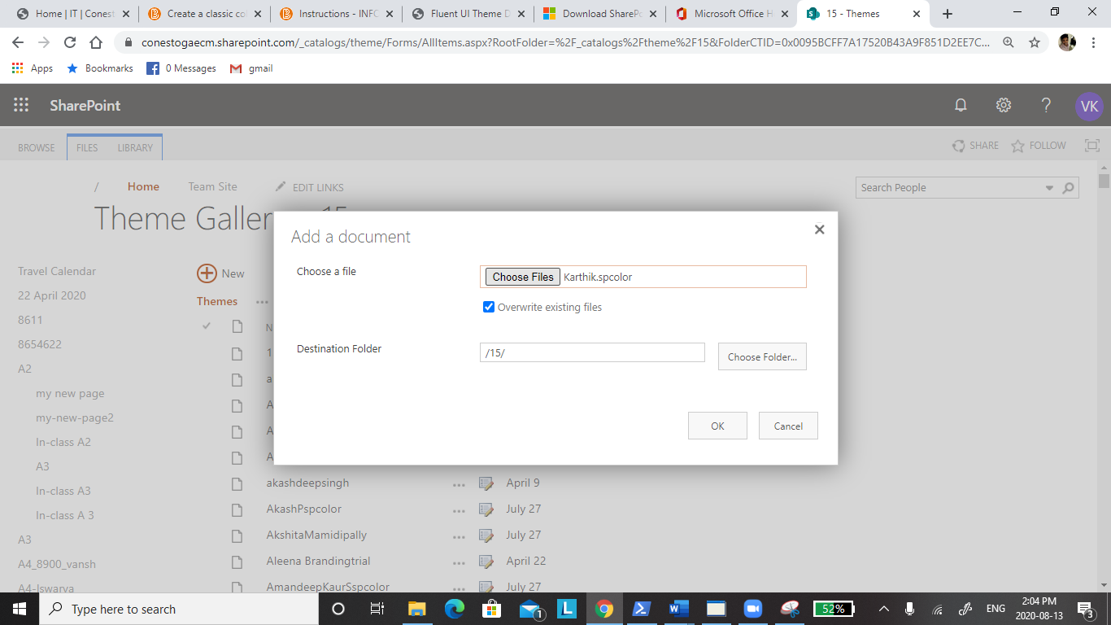

3) The uploaded spcolor is displayed as shown in below image.

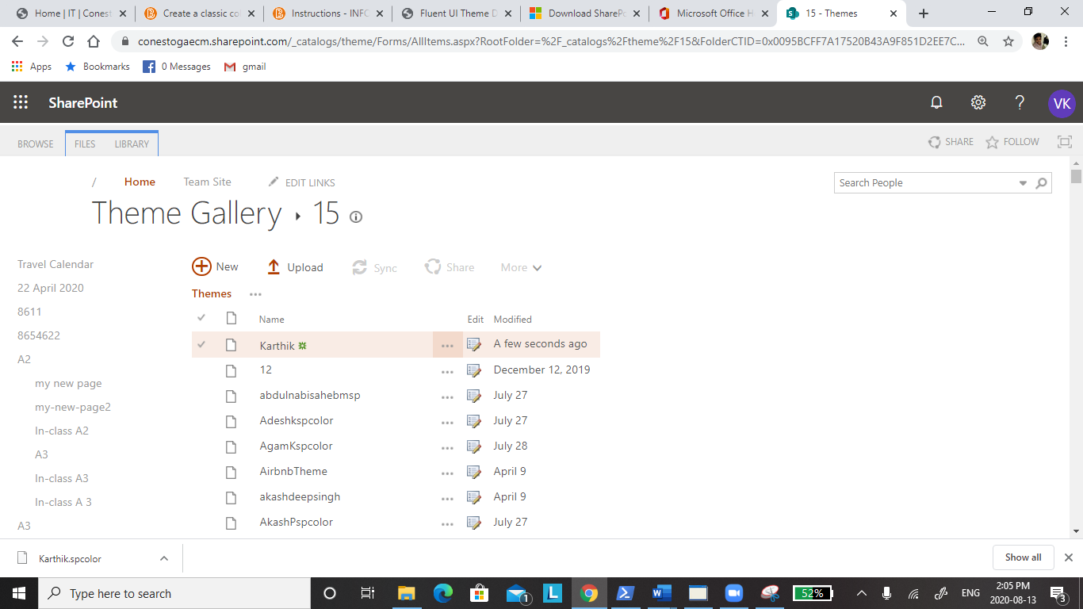

4) Creating the new theme as shown in below image

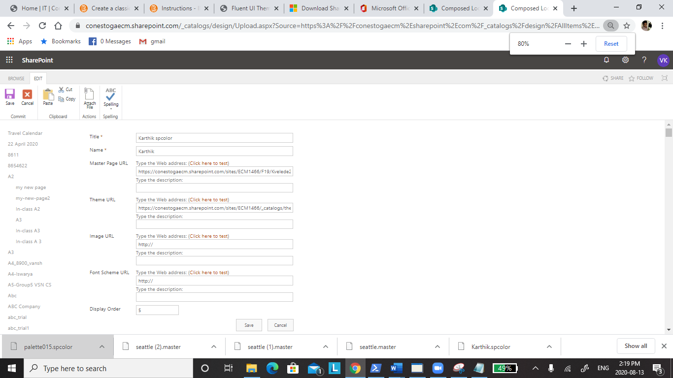

5) Now you can see the new theme in site settings

